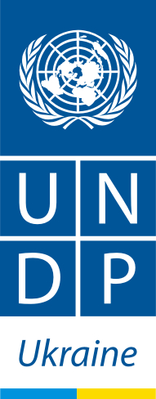
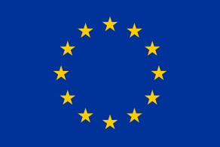
CBA-III Project
CBA Project. Phase III

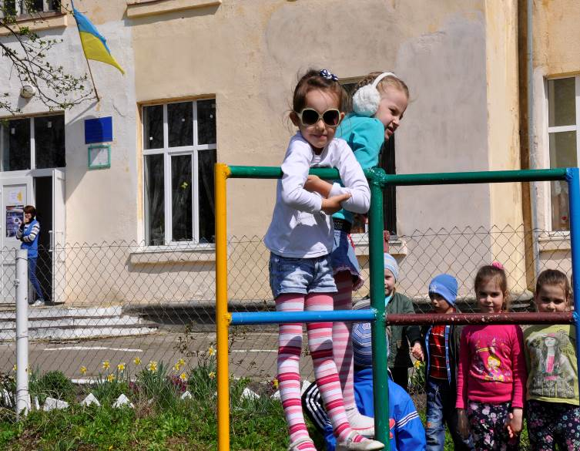

Community-based Approach to Local Development project
20 Esplanadna Str., office 704-708, Kyiv 01601
Tel: +38 (044) 253 5975, Fax: +38 (044) 253 5973
www.cba.org.ua
Facebook: www.facebook.com/cbaproject

PROJECT SNAPSHOT
• Timeframe: 2014 –2017
• Development partners: The project is implemented and co-financed by the United Nations Development Programme in Ukraine, and financed by the European Union.
• Implementing partners: community organizations, local and regional authorities, line ministries, parliamentary committees, national associations of local councils and academia
• Overall budget: 23.8 million Euro
- EU: 23 million Euro
- UNDP: 0.8 million Euro
- Geographic coverage: All regions of Ukraine
- Target groups: 1000 community organizations,300 ACMBs, 1000 village councils, up to 15 city councils, 200 rayon councils/administrations, 25 regional councils/ administrations.

CONTEXT
Phase III of the project continues to support traditional areas such as energy efficiency, health, environment and water management in rural areas, as well as to launch a new urban development component. The CBA will further promote small farm and non-farm businesses in rural areas. It will support the Ukrainian Government in developing policies in the area of decentralization and share innovative approaches and good practices on participatory governance and community-led local sustainable development through knowledge management hub and the curriculum of thirty three regional universities.

The Joint UNDP/EU Project “Community Based Approach to Local Development” (CBA) is a long-term and comprehensive capacity building initiative to promote sustainable local development in Ukraine. The Project supports participatory governance and community-led initiatives to improve living conditions of people in rural and urban areas throughout the country. The CBA has a specific focus on rehabilitation of social and communal infrastructure in the priority areas of health, environment, water management, improved management of housing sector, energy efficiency and local economic development.


Joint EU/UNDP Project
Community Based Approach to Local Development
ACTION
Phase I of the CBA Project commenced in 2008 and was succeeded by a second phase in June 2011. During these two phases, improved health services, access to clean water and waste management, learning environment and public safety were achieved through the participatory implementation of community projects - renovation of 1323 schools/ kindergartens, 599 health posts, 110 water supply, 17 environment, 556 energy-saving street illumination and 27 others.
- Promote community-based approach to local governance and sustainable development.
- Enhance energy efficiency at local level.
SPECIFIC OBJECTIVES
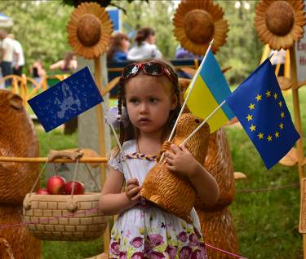
3. Support the creation of the locally owned and managed repository and network of good practices and knowledge on community mobilization and participatory governance.

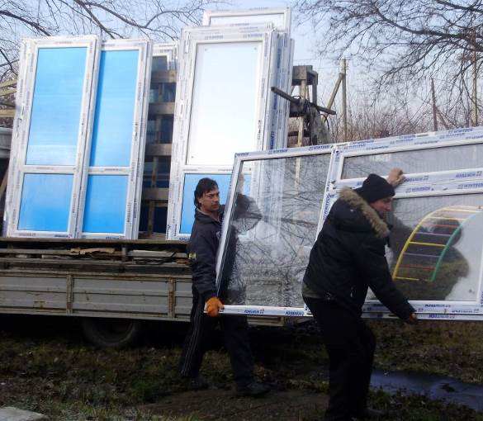

ESTIMATED RESULTS FOR CBA-III
- At least 800 rural community micro-projects will be implemented to improve communal services and economic development in rural areas, including at least 300 projects on energy saving / renewable sources of energy. At least 48 multi-functional non-

CBA In Data
- 2.6 million people in over 2, 000 villages and communities benefited from CBA-I and CBA-II
- More than 2,600 local development initiatives were carried
- 1323 schools/ kindergartens,
599 health posts,
110 water supply,
17 environment,
16 agricultural service cooperatives
556 energy-saving street illumination and 27 others
- More than 4500 people learnt about alternative energy resources and energy efficiency
- CBA supports 9 oblasts to address issues of IDPs. 29 objects were adjusted for temporary living of about 3,500 IDPs.
- 35 Universities became members of the National Network of Partner Universities

profit agricultural service cooperatives will be developed.
- Urban Development Component will support small cities with population 10,000 -150, 000 in 12 oblasts. To create a platform for collective actions and joint decision making at local level it is planned to create/strength :
- 300 ACMBs,
- up to 24 Municipal Support Units
At least 300 municipal projects will be implemented to improve living conditions of urban communities. 15 innovative municipal governance practices and tools will be introduced to improve public services in small cities.
- 200 community resource centres and 10 municipal resource centres will strengthen their capacity in community-based development.
- The curriculum on community-based development will be adopted by at least twenty regional universities.
- Support to the formulation and implementation of the decentralization reform will be provided. Knowledge management hub will serve as a platform for experience exchange.
RESULTS ACHIEVED AS OF 31 DECEMBER 2015
Since inception, the CBA Project established cooperation with 24 regions, 201 rayons, 800 village councils and 25 cities. The Project already trained around 4 ths. people in community based approach to local development.
As of the 31 December 2015 113 energy efficient, 351 energy saving, 48 health care, 31 water supply and 25 rural economic development micro-projects were approved for implementation, making total 543. More than 1,9 mln people in rural communities will benefit from the implementation of CBA-III Project. Besides, nearly 57 ths. people in urban communities will benefit from 206 urban community initiatives. 47 cooperatives were already created under the CBA-III methodology.
17 Universities out of 35 from the Network of the CBA Partner Universities introduced CBA methodology into theirs curriculum.

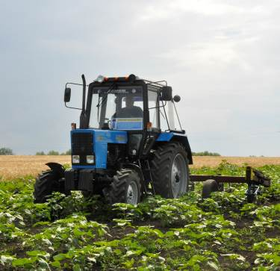
Joint EU/UNDP Project
Community Based Approach to Local Development

